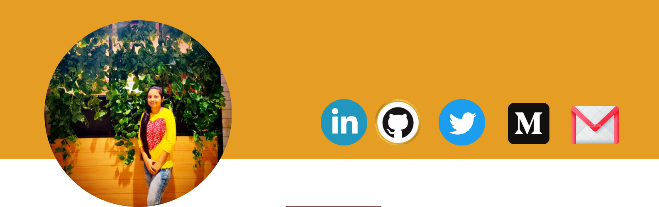
VAISHNAVI BARGE

ANDROID AND FLUTTER ENTHUSIAST

My Contact

vaishnavibarge2510@gmail.com 8767696098
Chinchwad Pune

Technical Skills

About Me

A Third Year Computer Engineering student at Dr. D.Y. Patil College of Engineering Akurdi Pune. Highly organized and detail-oriented student with an attitude to learn and explore new technologies.Android Enthusiast trying to learn new things about Flutter. Improving my problem-solving and logic-building skills through competitive programming and also practicing DSA through solving related questions.

Projects

Android and Flutter App Development

Programming Languages: C++ , Dart, Java

Frontend Development: Html, CSS, JavaScript (Beginner)

Data Structures & Algorithms

Database: MySQL ,Firebase

Personal Expense Tracker App : Built using Dart and Flutter Freamework . It also gives satistical chart which represents our expense ratio within a week

GrocShop App: Android App built using Kotlin where we can add grocery items to list and delete it

Quiz App: DSA Quiz App using Flutter

Responsible Positions and Achievements

Web development Intern at Waves Woman empowerment

Soft Skills

0

Problem Solving

0

Teamwork

Multitasking

PR a lead at GDSC-DYPCOE (Google Developer Students Club)

Publicity Head at ACES

Earned 22 Badges in Android Development on Google Developer Profile

Public Speaking |  | Education Background
Leadership
Hobbies |  | 2020-2024 | BE Computer (Currently in TE)CGPA: 9.48
 |  |  | Dr.D.Y.Patil College of Engineering, Akurdi, Pune
Mobile Photography |  | 2018-2020 | SMV College Akurdi,Pune HSC Score: 86.31 %
0 |  |  | 0
Playing Badminton |  | 2017-2018 | Dr.D.Y.Patil English Medium School, Pradhikaran,
 |  |  | SSC Score: 95.6%

